Remote diagnostic and predictive maintenance for transport system

|  |  |  |
| --- | --- | --- |
|  |  |  |
| Oruganti Sri Manasa | Bhavya Gumber | Dr. Saurabh Rana |
| *SCSET* | *SCSET* | *SCSET* |
| *Bennett University* | *Bennett University* | *Bennett University* |
| *Greater Noida, India* | *Greater Noida, India* | *Greater Noida, India* |
| E20CSE256@bennett.edu.in | E20CSE245@bennett.edu.in |  |

***Abstract*— The railway industry has an opportunity to implement IoT-based predictive maintenance for frequently used active equipment, such as the signaling department's critical systems, including Track Circuit, Point Machine, and Signals. Instead of relying on periodic maintenance, a condition-based predictive maintenance system can be used, providing advanced warning of possible failures. Predictive analysis using AI and deep learning techniques can reduce disconnection memo, Mean Time to Maintenance, and operating and maintenance costs.**

**Keywords— *IoT, Predictive, Event Logger, Track Circuit, Point Machine, Signals, Machine Learning, Artificial Intelligence***

# Introduction (*Heading 1*)

The Indian Transport is a government entity that operates India's national railway system, which is the third-largest in the world with a route length of 68,155 km. Railway signaling is crucial for directing traffic and preventing train collisions, and it relies on key components such as Point Machines, Track Circuits, and Signals. Maintenance of these components is critical for preventing failures and accidents. Condition Monitoring and Predictive Analysis can aid in identifying potential problems before they occur.

Cutting-edge technology such as Machine Learning, Artificial Intelligence, and IoT can be utilized to achieve predictive analysis and condition monitoring. However, data is a crucial prerequisite for all these technologies. In order to collect data continuously, voltage and current parameters can be measured using an Event Logger data acquisition unit. It is also crucial to ensure the safety of existing railway circuits by measuring data in a nonintrusive manner.

*Point Machine*

|  |
| --- |
| XXX-X-XXXX-XXXX-X/XX/$XX.00 ©20XX IEEE |

A Point Machine is a tool that facilitates the operation of railway turnouts from a distance. It utilizes an electric motor and gear system to transform the motor's rotational motion into linear motion.

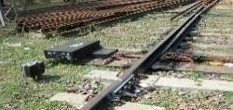

Fig.1

***Working of Point Machine:***

The point operation can be carried out either by an electrical DC motor or by using a mechanical lever that is connected to a shaft. The operation can be initiated through a twoposition switch, two buttons on a panel, or a lever in the cabin that is controlled by the station master. As the relays are in an interlocking state, they can be operated by a single knob. LEDs are used to indicate the normal and reverse positions of the point to the station master.

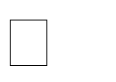To Monitor the Point Machine following parameters need to be measure: Operating Voltage

* Peak Voltage
* Peak Current
* Operating Current
* Obstruction Voltage
* Obstruction Current
* Operating Time

|  |
| --- |
| * TPR Relay Voltage * Obstruction Time *DC Track Circuit:*       The probability of point motor failure is heightened due to  DC track circuits are employed to  detect whether a rail track  is occupied or unoccupied. These circuits consist of several  sections, each with a maximum length of 450 meters.  Voltage is supplied at the feed end, and when a train enters  the section, the voltage at the relay end drops to zer  o due to  a short circuit. This causes the track relay to switch to the  "Drop" state.      *Working of DC Track Circuit:*      ***Fig.3***          **PROBLEM STATEMENT**    **A.**    **Point Machine**    Point machines are used to switch trains from one track to  another. They are typically located some distance away from  the station. However, using the point machine can cause  delays as there may be obstacles between the train and the  rails. I  n some cases, the point may be set and locked, causing  an obstruction for the next operation of the point machine. |

**Fig.2**

In the above fig shows the unoccupied and occupied condition of DC track circuit. Where station master can know the status and direction of the track.

In DC Track Circuit, following are the important parameters to be monitored: Feed Voltage & Current at

Feed End

* Relay Voltage & Current at Relay End
* TPR at Relay End
* Choke voltage
* Charger output voltage & Current
* Charger Input Voltage

***Signals***

Railway signals are visual displays that guide train drivers about when and how they can proceed. They give instructions and warnings to the driver about speed limits and when to stop. The driver reads the signal and follows its direction.

In Signal, following are the important parameters to be monitored:

* Each aspect Voltage and Current

the multitude of active components. Inadequate lubrication can cause the motor to consume excessive current beyond its typical operating range. Unsafe conditions may arise from incorrect application of pressure to the lock nut rods.

*B.* ***DC Track Circuit***

*A. DC Track circuits rely on a feed voltage from a battery, which needs to be constantly charged by a track feed battery charger. However, this charging process can lead to the development of leakages, ballast resistance, and track resistance. It's important to maintain these parameters within acceptable limits to ensure proper operation. Therefore, it's crucial to monitor and regulate these parameters to avoid exceeding their permissible range.*

The charger often fails or shuts down, resulting in inadequate delivery of voltage to charge the battery. To filter out unwanted noise in the voltage, a choke is used, but if the coil of the choke fails, it can cause voltage spikes to occur.

Sometimes, when a train enters or exits a certain section of track, the corresponding track circuit fails to clear and instead indicates that it is occupied, even though it should be unoccupied. This can be a problem as it can cause confusion and potential safety hazards.

Track circuits gets fails due to 24 V External DC Supply or relay fails, sudden break of jumper cable or fuse blown off.

As command, and use the naming convention prescribed by your conference for the name of your paper. In this newly created file, highlight all of the contents and import your

*B.* ***Signals***

Failures in signals are often caused by various issues such as blown fuses, leakage in quad cables, gradual decrease in load current, incorrect signal operation, and signal bobbing. These factors can lead to signal malfunction and result in disrupted communication. To avoid these issues, it is important to regularly check and maintain signal components, ensure proper installation and operation, and promptly address any malfunctions. By doing so, signal reliability can be improved and communication can be ensured.

III. **PROPOSED SOLUTION**

The Event Logger RTU is a microprocessor-based unit that continuously monitors voltage and current at the outdoor

cable termination point. It uses communication media such as Zigbee/LoRA/LTE/Ethernet to send data to the

cloud/server. With the help of an IoT and AI-ML Platform, real-time analytics on the data can be obtained, and various machine learning algorithms like linear regression and ARIMA models can predict future gear failures.

The solution architecture demonstrates how signaling gears can be monitored using a data acquisition system, sensors,

and IoT systems. The RTU device collects data and sends it

to the cloud via MQTT protocol. The server/cloud processes data streams, generates reports and alerts, which can be accessed in real-time via web and mobile apps.

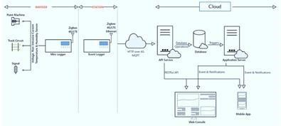

Fig.4 Solution Architecture

1. Measuring and isolating all voltage and digital input points, with AC voltage measurement using true RMS for

greater accuracy, and DC measurement with a scanning rate of less than 10ms to detect instantaneous spikes. Current

measurement is done non-intrusively using open loop hall

effect current transducers with high accuracy. Point machine current signature is sampled at a rate of 10 msec, and peak current is measured using sensors with a low scanning rate

and high response rate. Track circuit current measurement is in milli-amperes for improved accuracy.

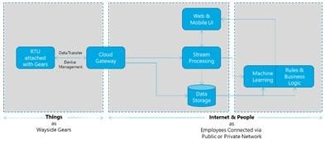

Fig.5 IoT Architecture

1. Communication and data transfer can be done using available and appropriate communication media, such as

LTE/4G/NB-IoT, LoRA/WIFI/Zigbee local network, OFC,

Ethernet, or Quad Cable. Data can be transferred from the

RTU device to the server/cloud using any of these methods.

1. Data is stored in a centralized database

* The data is stored in a centralized database, but can also be logged locally in case of network failure.
* Real-time data processing and analytics are available through an application.
* Microservices are provided to integrate machine learning algorithms with the data.
* Timeseries data can be used to predict future trends.
* Warnings can be sent to the relevant people to prevent potential failures.
* A powerful rule engine allows users to set thresholds and receive alerts for various parameters.
* Visual analytics are available through various charts and graphs.

**RESULTS AND DISCUSSION**

The findings are derived from the operational framework employed by North Central Railway. Data on point

machines, track circuits, and signals are accessible. Ongoing experiments aim to enhance the maintenance of S&T equipment across the entire system.

*Point Machine*

The graph illustrates three different scenarios: normal operation, point obstruction, and abnormal operation. In normal operation, the operation is completed within 2-3

seconds. Abnormal events take more time and current to

complete the operation. There is also a point in the graph where the operation takes the maximum current and time exceeds 6 seconds due to an obstruction between the sleepers.

The below graph shows when the point machine starts its operation currents goes to peak and after 1 sec it

gradually decreases and continues till its steady operation ends, before set and lock again the current increases and goes down to zero.

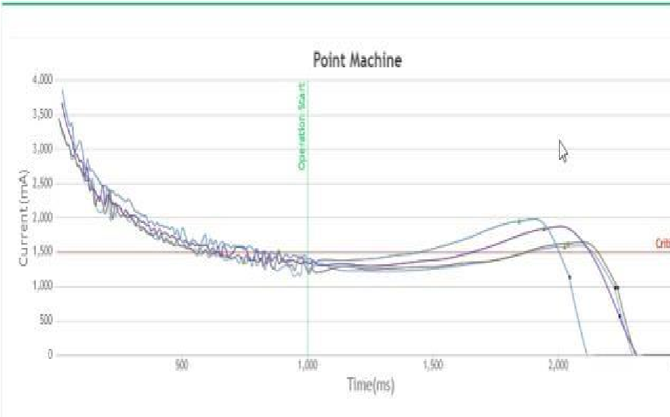

Fig.6 Normal Operation

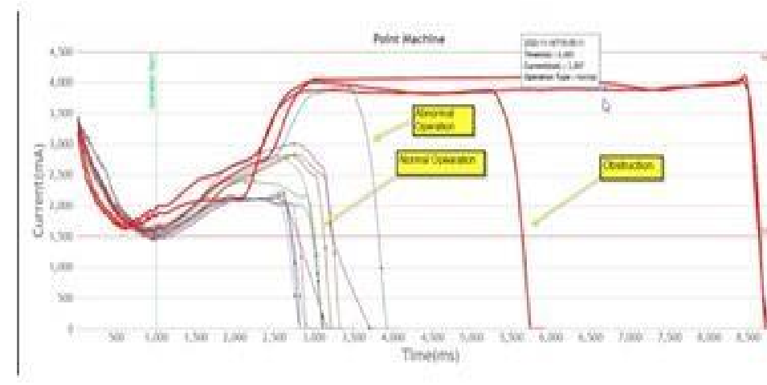

Fig.7 Obstruction, Abnormal, Normal operation

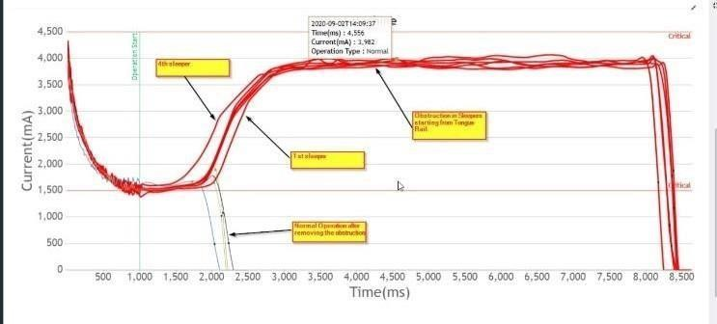

Fig.8 Obstruction in Different sleepers

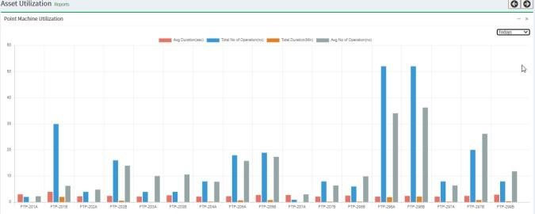

Fig.9 Utilization Reports of Point

*DC Track Circuits*

In DC Track Circuits, it has been noticed that the presence of rain on the track causes a gradual increase in leakage. This results in a decrease in voltage at the feed and relay, leading to a failure in the Track Circuit. Providing a prior alert about the heightened leakage can assist the maintenance personnel

in effectively maintaining the track circuit. .(Refer Fig.10)

Track chargers sometimes fail to charge the battery during maintenance, causing the track to run on battery power.

After a certain period, the battery eventually fails due to the lack of charging. To prevent this, it would be useful to

predict when the track will fail after the charger stops working.( Refer Fig 11)

The graph in Figure 12 shows the specific reason for the failure of the track circuit when there is a break in the jumper cable or continuity bond. This information can assist maintainers in identifying the underlying cause of the problem.

|  |
| --- |
| 1. It is advisable to use a remote diagnostic and predictive |

(Fig.11) TC going to fail due to charger fail

(

Fig.10) Increased Leakage

**ROADMAP AND FUTURE CHALLENGES**

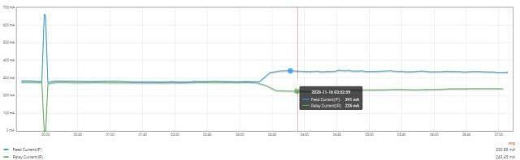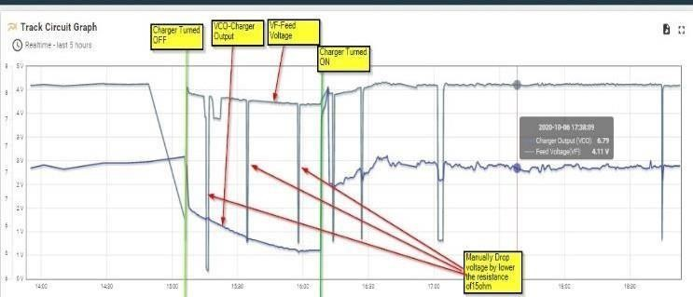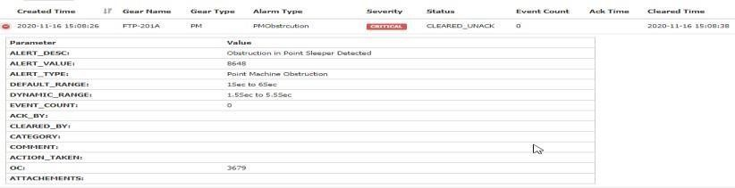

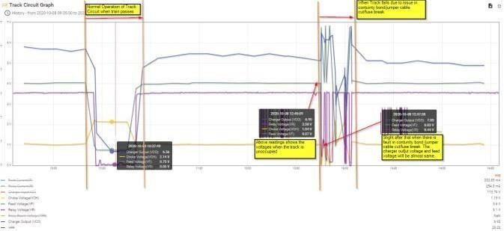

(Fig.12) TC Failure due to continuity bond cut

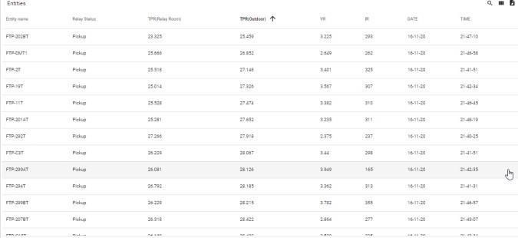

(Fig.13) Relay Room Status

*Alerts and Alarms*

maintenance system during trials conducted on multiple stations and with multiple gears to gather large datasets that can be used to train and optimize machine learning algorithms.

2. A plan should be put in place for the calibration of sensors. 3. The system should be able to work seamlessly with various vendors.

**CONCLUSION**

Yes, implementing a system to monitor the condition of railway signalling equipment and predict maintenance requirements can provide significant benefits to transport. By monitoring the performance and health of the signaling equipment in real-time, the system can help detect and diagnose potential issues before they result in major failures or outages. This can help reduce the MTTR (Mean Time to Repair) and improve the MTBF (Mean Time Between Failures), which are important metrics for measuring the signalling system's reliability and availability.

There are various approaches to putting such a system in place. One approach is to collect and analyse data from signalling equipment in real-time using sensors and data analytics tools. The data can then be used to create predictive models that predict potential failures or maintenance requirements. Machine learning algorithms can be used to detect patterns and anomalies in data, as well as to make predictions based on past data and other relevant factors.

Another approach is to use condition-based maintenance (CBM) techniques, which involve monitoring the condition of the signaling equipment and scheduling maintenance based on the actual condition of the equipment rather than on a fixed schedule. CBM can help to reduce maintenance costs and downtime while also extending the life of signalling equipment.

Overall, implementing a system for monitoring the condition of railway signalling equipment and forecasting maintenance needs can help improve the railway system's safety, reliability, and efficiency. Transport can reduce downtime, improve operational efficiency, and provide a better customer experience by detecting potential issues early and proactively scheduling maintenance.

24x7 online monitoring of the gears will reduce the periodic maintenance activity and reduction in manpower.

***ACKNOWLEDGMENT***

The adoption of IoT and AI-ML technologies in the Indian railway system has transformed how it operates. These advanced technologies have been seamlessly integrated into the railway infrastructure with the help of the North Central Railway, resulting in increased safety, efficiency, and customer satisfaction.

The ability of IoT and AI-ML to provide real-time monitoring and analysis of various aspects of the railway system is one of their primary advantages. Sensors, for example, can be used to monitor the condition of railway tracks, engines, and other critical components. This data can then be analysed with AI-ML algorithms to identify potential issues before they become major issues. This proactive maintenance approach has reduced downtime, improved safety, and increased the overall reliability of the railway system.

Furthermore, IoT and AI-ML technologies have enabled the Indian railway system to improve customer service. For example, railway operators can anticipate demand and adjust services accordingly by analysing passenger data, ensuring that trains run on time and have enough capacity to meet passenger needs. This has resulted in increased customer satisfaction and ridership.

Overall, the integration of IoT and AI-ML into the Indian railway system has been transformative. This technology, with the help of the North Central Railway, has enabled the railway system to operate more efficiently, safely, and reliably, while also providing better service to customers.

**ABBREVIATIONS**

AI – Artificial Intelligence

ML- Machine Learning

RTU- Remote Terminal Unit

IoT – Internet of Things

MQTT- Message Queuing Telemetry Transport

LTE – Long Term Evolution

NB-IoT- Narrow Band- Internet of Things TPR- Track Point Relay

**REFERENCES**

[1]. CAMTECH Gwalior, “Handbook on Condition

Monitoring of Signalling Assets”, in SP7 1.7, Maharajpur Gwalior MP,Feb 2018, pp. 03–25.

[[2]. https://standardscatalog.ul.com/ProductDetail.aspx?pro ductId=UL157](https://standardscatalog.ul.com/ProductDetail.aspx?productId=UL157)

[3]. Roy, Debasish. ["Why isn't the Transport a PSU?", Th](https://economictimes.indiatimes.com/why-isnt-the-railways-a-psu/articleshow/7584262.cms?from=mdr)e Economic Times. Retrieved 23 August 2020.

[4]. Paula Fraga-Lamas,” Towards the Internet of Smart Trains: A Review on Industrial IoT-Connected

Transport”, Department of Computer Engineering, Faculty of Computer Science, Universidade da Coruña, June 2017.

**IEEE conference templates contain guidance text for composing and formatting conference papers. Please**

**ensure that all template text is removed from your conference paper prior to submission to the**

**conference. Failure to remove template text from your paper may result in your paper not being published.**